PRT661

Energy Demand Forecasting System
WP1 / Stage 1 — Data Acquisition and Source Management
Purpose: document how the project acquires, preserves, validates and organises source data before the acquisition stage is closed.

Document Control
Item | Final WP1 definition
Primary implementation file | 01_Data_Acquisition_Final_Integrated.py / Data_Acquisition_reworked.py
Historical acquisition start | 2022-01-01 by default
Final automated demand scope | NSW1, QLD1, VIC1, SA1, TAS1 and WA
Historical weather source | Open-Meteo ERA5 reanalysis — daily and hourly
Live weather source | ECMWF IFS HRES through Open-Meteo — next 7 full local days; generic Open-Meteo forecast is logged fallback
Market sources | AEMO NEM monthly archive, AEMO dashboard API, AEMO WA/WEM sources and 2026 WA Market Requirements
Calendar source | Australian state public-holiday calendars using the Python holidays package
Primary output locations | price_and_demand/, energy_requirement/, dispatch/, predispatch/, snapshots/ (optional), weather/, public_holidays/, DATA_NOTES.md

Executive Summary
WP1 establishes the source layer of the Australian Electricity Demand Forecasting project. The final acquisition program collects market-demand history, live market snapshots, Western Australian market data, historical weather, rolling seven-day forecast weather and state public-holiday calendars while preserving the identity and timing of each source. The emphasis is reproducibility: raw source characteristics are retained, forecast vintages can be archived, and one unavailable provider does not prevent the other acquisition activities from completing.
The implemented WP1 differs materially from the original Assessment 1 design. Assessment 1 proposed seven demand regions, including Darwin–Katherine (NT), and specified Bureau of Meteorology Climate Data Online as the weather source. Source investigation later showed that NT historical demand could not be obtained through the same reproducible automated bulk-download pattern used for the other regions, while the original BOM acquisition route produced HTML/ZIP handling failures and did not provide the required rolling forecast-vintage workflow. The team therefore narrowed the automated demand scope to six regions and replaced the weather path with Open-Meteo ERA5 for historical reanalysis and ECMWF IFS HRES through Open-Meteo for the live seven-day forecast.
A second important change concerned Western Australia. The implemented WEM pipeline preserves the native source regime rather than forcing the data into one assumed interval: legacy operational-demand records are retained at 30-minute resolution through 30 September 2023, and the modern WEM source is retained at 5-minute resolution from 1 October 2023. This evidence-led revision makes WP1 a source-faithful acquisition layer rather than a stage that silently changes the data.

1. Purpose and Scope
This report is intentionally limited to WP1 / Stage 1. It records the original acquisition plan, the source problems discovered during implementation, the decisions taken by the group, the final source architecture and the files produced by the integrated acquisition program. It does not document later analytical transformation or modelling work.

1.1 Objectives
- Create a repeatable acquisition workflow for the six final electricity-demand regions.
- Keep source families separate so every output can be traced to its provider and purpose.
- Preserve native source characteristics, especially WA interval frequency and AEMO PERIODTYPE.
- Acquire both historical weather and a genuine forward weather forecast without relabelling forecast values as observations.
- Archive time-sensitive forecast vintages when requested so later comparisons can reproduce what was actually known at the time.
- Generate state-specific public-holiday calendars through the complete project horizon.
- Use response checks, timeouts, logging and source-level failure isolation so one broken source cannot invalidate the whole acquisition run.

2. From Assessment 1 Plan to Final WP1 Design
The initial proposal provided a strong conceptual direction but assumed that all planned sources could be automated in the same way. WP1 implementation tested those assumptions against real provider behaviour. Where the evidence did not support the original source choice, the group changed the acquisition design and recorded the reason rather than hiding the mismatch.
Area | Assessment 1 / early plan | Issue discovered during WP1 | Final WP1 decision
Geographic scope | Seven demand regions: five NEM regions, WA and Darwin–Katherine (NT). | A reproducible automated bulk historical NT demand feed was not established; the available route required a manual historical-data request. | Final automated demand scope reduced to six: NSW1, QLD1, VIC1, SA1, TAS1 and WA. NT is not downloaded by the final script.
Weather | BOM Climate Data Online; early code attempted station-based daily maximum temperature, minimum temperature and rainfall. | Saved “CSV” outputs were found to contain HTML or ZIP-handling artefacts. The route also did not solve the need for a reproducible live forecast vintage. | Historical weather changed to Open-Meteo ERA5. Live weather changed to ECMWF IFS HRES via Open-Meteo for the next seven full days, with a logged generic Open-Meteo fallback.
WA demand | A common half-hourly regional target was assumed at proposal stage. | AEMO WEM source structure changes on 1 October 2023; legacy and modern data have different native intervals. | Preserve 30-minute legacy data through Sep 2023 and 5-minute modern WEM data from Oct 2023, recording SOURCE and SOURCE_INTERVAL_MIN.
Live market context | Current and future AEMO information was part of the project concept. | Dashboard dispatch and pre-dispatch responses can contain both ACTUAL and FORECAST rows; endpoint name alone is not enough. | Keep dispatch and pre-dispatch in separate folders, preserve PERIODTYPE, and optionally archive timestamped snapshots.

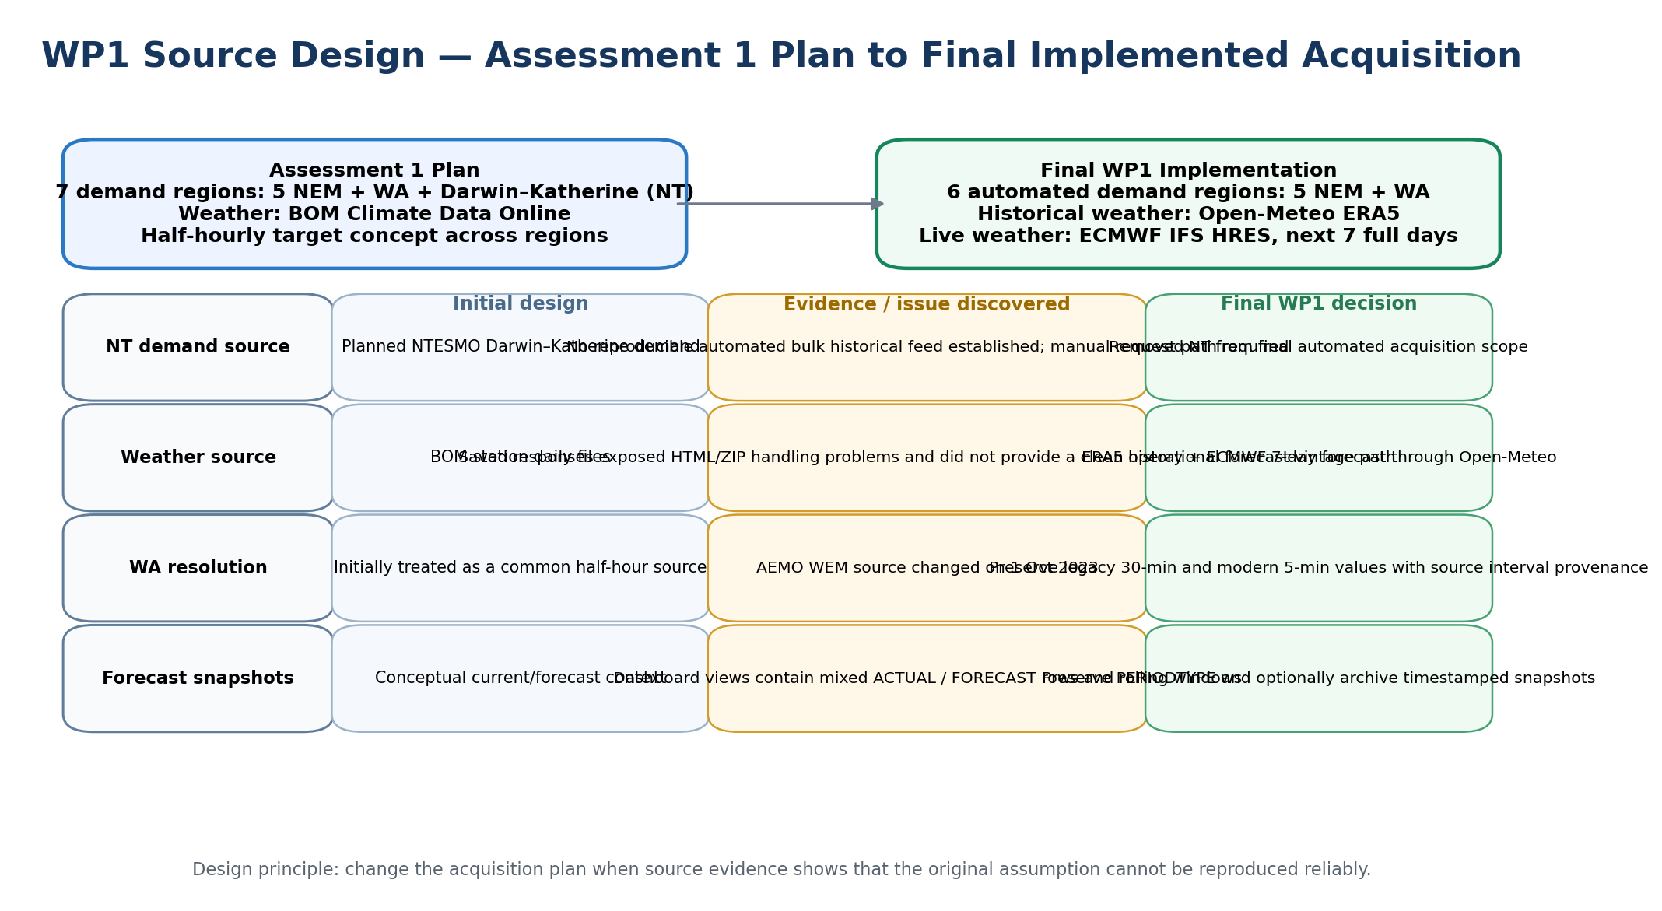
Figure 1. Evidence-led evolution from the Assessment 1 source plan to the final WP1 acquisition design.

3. Final WP1 Data Acquisition Architecture
The final architecture remains source-aligned. Each external source family is handled through a clearly bounded acquisition responsibility, then the functions are combined into one executable script. This keeps provider-specific rules visible while still giving the group one reproducible entry point for a complete acquisition run.
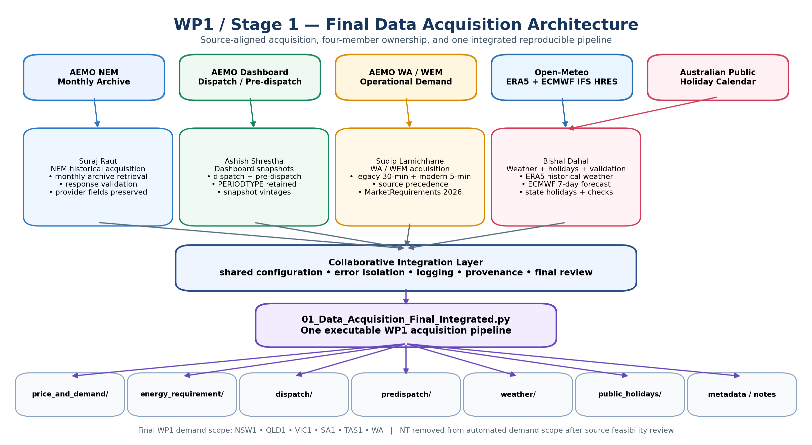
Figure 2. Final WP1 architecture: external sources, individual workstreams, collaborative integration and acquisition outputs.

4. Final Region and Source Configuration
The final integrated script contains six region definitions: NSW1, QLD1, VIC1, SA1, TAS1 and WA. The five NEM regions share the AEMO monthly archive and dashboard source families. WA is acquired from WEM-specific source families because its market structure, file formats and historical interval regimes differ from the NEM sources.

4.1 Why NT is not in the final automated acquisition scope
Assessment 1 included Darwin–Katherine as a seventh demand region. During implementation, the team could not establish a stable automated bulk historical download that met the same reproducibility standard as the NEM and WEM sources. Earlier code therefore wrote an explicit NT_DATA_NOT_AVAILABLE note stating that historical data required a manual request to the NT operator. The final v8 acquisition script removes NT from REGION_CONFIG entirely rather than continuing to create weather/holiday files for a region that has no matching automatically acquired demand target. This is a scope correction based on source feasibility, not an assumption that NT demand is unimportant.

4.2 Source categories
Source family | Data acquired | WP1 purpose / safeguard
AEMO NEM monthly PRICE_AND_DEMAND archive | Per-region monthly history containing fields such as SETTLEMENTDATE, TOTALDEMAND, RRP and PERIODTYPE. | Build one consolidated raw history per NEM region while preserving provider columns and original timestamp text.
AEMO dashboard API | Dispatch 5MIN and pre-dispatch 30MIN views for the five NEM regions. | Preserve PERIODTYPE; keep the two views separate; optionally archive time-stamped snapshots.
AEMO WA / WEM | Legacy operational demand, modern operational-demand/withdrawal files and recent daily top-up files. | Construct WA history across the 2023 system cutover while retaining native interval provenance.
AEMO WA Market Requirements | MarketRequirements-2026.csv stored separately. | Prevent a forecast/requirement dataset from being mistaken for observed demand.
Open-Meteo ERA5 archive | Historical daily and hourly temperature, humidity and precipitation for six representative capital-city locations. | Provide reproducible historical weather with explicit source metadata.
Open-Meteo ECMWF Forecast API | Next seven full local calendar days of hourly forecast weather, primarily ECMWF IFS HRES. | Provide a genuine forward weather vintage, with source/model/origin/lead-day metadata and immutable archive copies.
Australian public-holiday calendars | State-specific dates, indicator and holiday name. | Create reproducible calendar inputs for NSW, QLD, VIC, SA, TAS and WA through the defined project horizon.

5. Data Acquisition Workflow
The integrated script exposes one command-line entry point and optional folder-selection interface. Each source family can be run or skipped independently, which supports controlled refreshes and makes provider failures easier to diagnose.

5.1 Output directory and run controls
If no output directory is supplied, the script opens a folder-selection dialog where available and otherwise falls back to a typed path. Runtime switches allow the user to skip the NEM archive, WA, dashboard, historical weather, forecast weather or holiday acquisition independently. The script also records a DATA_NOTES.md file explaining folder meaning and important source conventions.

5.2 NEM monthly historical archive
For each requested NEM region, the pipeline walks month-by-month from the acquisition start to the acquisition end and downloads AEMO PRICE_AND_DEMAND_<YYYYMM>_<REGION>.csv files. A shared requests session reduces repeated connection overhead. Before parsing, the response is checked for HTTP failure and for HTML bodies that can be returned when a requested month is unavailable. Monthly files are concatenated, sorted and deduplicated using a temporary parsed timestamp while the provider’s published columns and timestamp text are preserved in the written CSV.

5.3 Dispatch and pre-dispatch snapshots
The AEMO dashboard API is queried for two time scales: 5MIN for the Dispatch view and 30MIN for the Pre-Dispatch view. One response can cover all five NEM regions, after which the script writes one regional CSV per view. The acquisition code does not infer row meaning from the folder name alone: where PERIODTYPE exists, the ACTUAL/FORECAST composition is logged and the field remains in the raw output. If snapshot archiving is enabled, timestamped copies are also written so a rolling dashboard vintage is not lost when the next run refreshes the “current” files.
View | Time scale | Regional output | Key preservation rule
Dispatch | 5 minutes | dispatch_<REGION>.csv | Raw dashboard view; PERIODTYPE retained
Pre-dispatch | 30 minutes | predispatch_<REGION>.csv | Raw dashboard view; PERIODTYPE retained

5.4 WA / SWIS operational-demand acquisition
WA uses a dedicated acquisition path because the source family changes across the project history. The code identifies plausible timestamp and operational-demand fields structurally and deliberately rejects candidate demand columns containing “forecast” or “withdrawal”. The three WA source types are then merged with explicit precedence so the freshest valid source wins where records overlap.
Period / source | Native interval | Final WP1 handling
1 Jan 2022 – 30 Sep 2023 legacy WEM files | 30 minutes | Retained at native frequency; SOURCE_INTERVAL_MIN = 30
From 1 Oct 2023 modern WEM files | 5 minutes | Retained at native frequency; SOURCE_INTERVAL_MIN = 5
Recent tail where annual file lags | 5 minutes where available | Daily WEM files top up the latest period; overlap precedence favours daily data

5.5 WA 2026 Market Requirements
MarketRequirements-2026.csv is downloaded unchanged into energy_requirement/. The file is intentionally kept outside the demand directory because it is market requirement information rather than an observed demand record. The separation prevents later file discovery from accidentally treating it as the target series.

5.6 Weather acquisition — final design
Weather is the largest WP1 source change from Assessment 1. The original plan used BOM Climate Data Online and the early implementation attempted station files for maximum temperature, minimum temperature and rainfall. Validation later showed that apparently successful responses could contain HTML pages or ZIP content rather than usable observations. Instead of masking the problem, the team changed the source architecture.

5.6.1 Historical weather: Open-Meteo ERA5
Historical weather is requested from the Open-Meteo ERA5 archive for one representative capital-city coordinate in each of the six final regions. Daily variables are maximum temperature, minimum temperature, mean temperature and precipitation sum. Hourly variables are temperature, relative humidity and precipitation. The written files retain LOCATION, TIMEZONE, SOURCE_TYPE = OBSERVED_REANALYSIS and SOURCE = Open-Meteo ERA5. Because ERA5 is reanalysis rather than a real-time observation feed, the code also respects an expected publication lag instead of pretending the most recent days are already available.

5.6.2 Live weather: ECMWF IFS HRES through Open-Meteo
For forward weather, the script requests the next seven full local calendar days after the chosen forecast origin. The primary route is Open-Meteo’s ECMWF endpoint using ECMWF IFS HRES; if that request fails, the generic Open-Meteo forecast endpoint is attempted and the actual source/model used is recorded. Hourly forecast files contain temperature, humidity and precipitation together with SOURCE_TYPE, MODEL, RETRIEVED_AT_UTC, FORECAST_ORIGIN_DATE, TARGET_DATE and LEAD_DAY.
Two copies of each forecast run are written. weather/forecast/latest/ is refreshed for the newest run, while weather/forecast/archive/<timestamp>/ is immutable. The archive is essential because a weather forecast is a time-stamped information state: once a new forecast is issued, the previous one cannot be reconstructed honestly unless the vintage was saved.
Weather component | Resolution / horizon | Provenance retained
Historical ERA5 | Hourly + daily, 2022 to available ERA5 cutoff | Region, location, timezone, source type and source name
ECMWF forecast | Hourly, next 7 full local days | Source/model, retrieval time, forecast origin, target date, lead day
Forecast archive | One timestamped folder per acquisition run | Manifest + run metadata; previous vintages never overwritten

5.7 Public-holiday calendars
The holiday stage generates one state-specific calendar for each of the six final regions. The files contain the calendar date, state, a binary public-holiday indicator and the holiday name. The calendar end is extended to the end of the relevant project horizon so known future holidays can be acquired in advance rather than requiring manual spreadsheet maintenance.

5.8 Failure isolation, logging and provenance
Source acquisition is treated as a set of independent external operations. Network calls use timeouts; malformed responses are named near the source that caused them; critical source metadata is written with the data; and optional skip switches allow a failed provider to be retried without re-downloading every other source. The design principle is that a partial source failure should be visible and recoverable, not silently converted into fabricated values.

6. Final WP1 Output Structure and Evidence
The final acquisition run is organised by source purpose. This keeps observed histories, market requirements, live dashboard snapshots, weather histories, weather forecast vintages and calendars distinguishable at file-system level.
Stage1_Data/
├── price_and_demand/
│ ├── price_and_demand_NSW1.csv ... price_and_demand_TAS1.csv
│ └── WA_demand_2022_2026.csv
├── energy_requirement/
│ └── MarketRequirements-2026.csv
├── dispatch/
│ └── dispatch_<NEM_REGION>.csv
├── predispatch/
│ └── predispatch_<NEM_REGION>.csv
├── snapshots/ # optional dashboard vintages
├── weather/
│ ├── weather_daily_<REGION>.csv
│ ├── weather_hourly_<REGION>.csv
│ └── forecast/
│ ├── latest/
│ └── archive/<UTC_timestamp>/
├── public_holidays/
│ └── public_holidays_<REGION>_<STATE>.csv
└── DATA_NOTES.md

6.1 Acquisition checks performed at source boundary
Control | Applied to | Purpose
HTML/error-body detection | NEM archive and WA Market Requirements | Avoid treating an error page as CSV data
Schema/field detection | WA source families | Identify timestamp and operational-demand fields while rejecting forecast/withdrawal columns
Timestamp deduplication for consolidated histories | NEM monthly archive and WA merged history | Prevent repeated intervals when overlapping source files are combined
Native interval provenance | WA | Keep evidence of 30-minute versus 5-minute source regime
Forecast date coverage check | Seven-day weather forecast | Reject a forecast response that does not contain every requested target date
Forecast vintage archive | Weather forecast and optional dashboard snapshots | Preserve the information that actually existed at the time of acquisition
State/calendar mapping | Public holidays | Keep holiday dates aligned to the correct Australian state

7. WP1 Team Contribution and Integration
The source-aligned split from the original WP1 plan is retained, but the final responsibilities reflect the real changes made during implementation. Individual modules provide traceable ownership; the final executable script is a group integration artefact.
Member | Primary acquisition responsibility | Final contribution boundary
Suraj Raut | AEMO NEM monthly archive | Historical NEM retrieval, consolidated regional files, response checks and preservation of provider fields.
Ashish Shrestha | AEMO dashboard dispatch / pre-dispatch | Regional snapshot export, PERIODTYPE preservation and optional timestamped snapshot storage.
Sudip Lamichhane | WA / WEM acquisition | Legacy + modern WA source assembly, native interval provenance, structural demand-field detection and separate Market Requirements download.
Bishal Dahal | Weather, holidays and acquisition verification | Weather-source validation; final ERA5 + ECMWF path; state holiday generation; checks that source outputs are real data rather than malformed responses.
Dan6 jointly | Integrated acquisition pipeline | Shared region configuration, execution order, source-failure handling, folder design, notes/provenance and final code review.

8. WP1 Risks, Limitations and Controls
Risk / limitation | Potential effect | WP1 control / response
External provider unavailable or schema changes | A source refresh may fail or return a differently structured payload. | Timeouts, response checks, source-local logging and independent skip/rerun controls.
Dashboard windows are transient | An older forecast/dispatch state may disappear after the provider refreshes it. | Optional timestamped snapshot archive; weather forecasts always archive immutable vintages.
Weather location is one representative city per region | Regional climate variation is not fully represented by a single coordinate. | Location is explicitly recorded; no claim is made that the site represents every subregion equally.
ERA5 trails real time | Most recent historical weather days may not yet be available. | The code applies an expected ERA5 lag and does not fabricate missing recent observations.
WA changes source regime in 2023 | Treating all WA rows as one native interval would misrepresent the provider history. | SOURCE and SOURCE_INTERVAL_MIN preserve the two regimes.
NT removed from automated scope | The final acquisition layer no longer produces Darwin–Katherine demand. | Scope change is documented explicitly; no placeholder NT demand is manufactured.
AEMO fields may have different market semantics | A field can be mislabelled if its source meaning is assumed rather than preserved. | Stage 1 keeps provider field names, PERIODTYPE and folder/source separation rather than renaming raw records into unsupported concepts.

9. Conclusion
WP1 progressed from a seven-region, BOM-centred acquisition proposal into a six-region automated source layer that better reflects what can be collected reproducibly. The final implementation retains the strong parts of the original plan — source separation, per-region acquisition, WA independence, weather/calendar context and reproducibility — while changing the parts that real provider behaviour proved unreliable. NT was removed from the final automated demand scope, BOM was replaced by a historical ERA5 plus live ECMWF weather architecture, WA native interval changes were preserved rather than normalised away, and time-sensitive forecasts gained explicit vintage archiving. WP1 therefore closes with a transparent, source-faithful acquisition package rather than a collection of files whose provenance or timing has been lost.

